- Renal blood flow for preferred hypotension drugs - fenoldapam, SN, nitro, labetalol
    - Looked this up and couldn’t find a definite answer. I do know that fenoldopam is beneficial for RBF

- Cvp wave form - ekg correlation. C wave - just after QRS (c on the s) – this is BIG
- Wigger loop and ekg correlation.
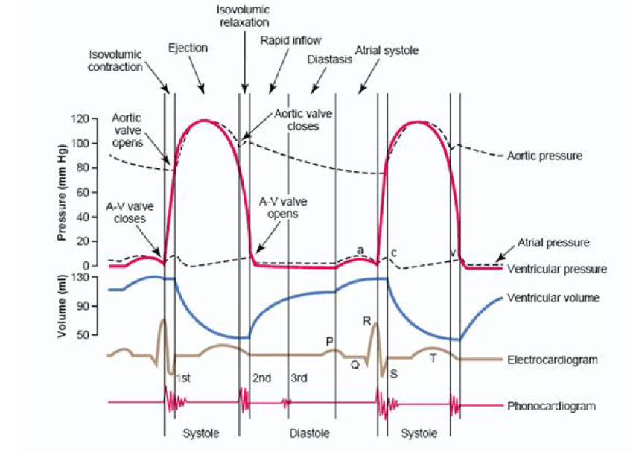
- Ax block - BP cuff - intercostobrachial
- HIV exposure - when to start treatment - 72 hours
- BMI - kg/ m2
- CI - SVxHR/BSA
- parkland
- Fetal Heart rate wave forms – VEAL CHOP
- LAST Bier Block - shivering and facial twitch. What do you do.
  - Intubate, Give a Benzo, or Release the torniquet
  - It was insinuating that LAST was developing.
  - Looked up in valley
- Similarity of geriatrics lung function and lung disease
- Pain stimulus NT release - bradykinin histamine serotonin
- Systolic heart failure - eccentric/ regurg??
- Which views are in line during laryngoscopy?
    - LA and PA
- Carbon monoxide and soda lime
  - Which inhalation agent causes the least amount of CO to be formed?
    - Des, Sevo, Iso, and N2O

- Flow volume loops and spontaneous respirations
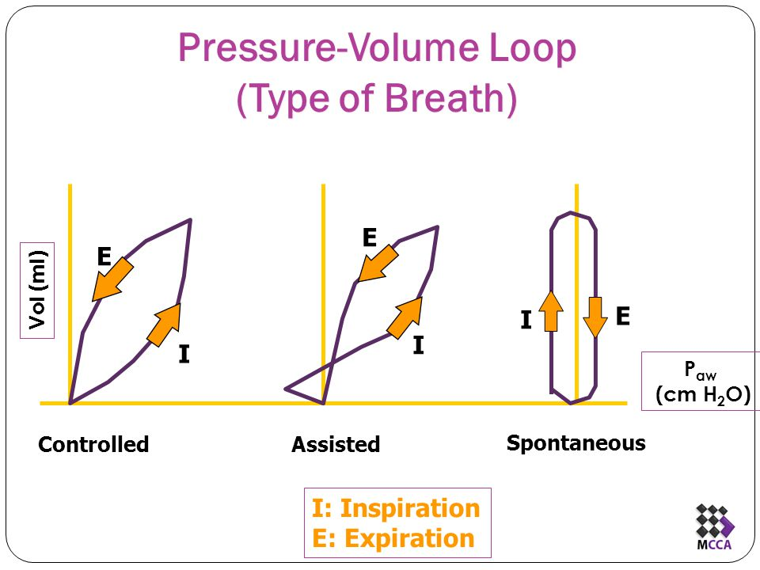
Looked similar to this on the test

- Geriatric patients and cognitive dysfunction post surgery. Not delirium.

- Liver. – Kuppfer Cells and Sinusoidal
- Nerve injury on MEDIAL side of leg in stirrups.
    - I put saphenous
- Cystic Fibrosis – anesthesia management
- Why do you give a smaller dose on OB spinal
- Fa/FI curve – high solubility
- Epi 1:1000 to 1:200,000
- Herbals that effect coag
- Muscular Dystrophy and Succs
- Bis Chart
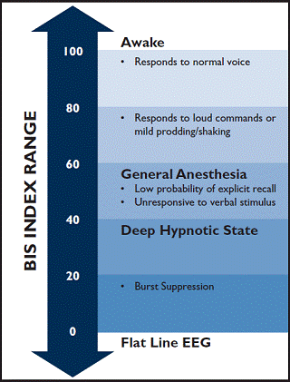
- I heavily relied on APEX and the second time I used Valley and APEX.

